Version 1.1

Game Design Document

Game Design Team Information:

|  |  |
| --- | --- |
| Team Name: | The Araguzers |
| Team Mentors: | Jose Baez-Franceschi, Dr. Chang Yun |
| Team Leader: | Michael Minkov, Jr. |
| Assistant Team Leader: | Nashid Shabazz |
| Storyboard Sketcher: | Nashid Shabazz |
| Storyline Designer: | Michael Minkov, Jr. |
| Intro Cinematic: | Michael Minkov, Jr. |
| Level Designers: | Eddie Grigoreff, Michael Minkov, Jr. |
| Protagonist Designers: | Eddie Grigoreff, Isiah Aideyan |
| Weapon Designer | Isiah Aideyan |
| Antagonist Designer: | Isiah Aideyan |
| Common Enemy (Dog) Designer: | Michael Minkov Jr., |
| Corked Bottle Designer | Michael Minkov, Jr. |
| Vehicle Designer: | Michael Minkov, Jr. |
| Terrain Designers: | Nashid Shabazz, Michael Minkov, Jr. |
| Main Programmer/GameEngine Designer : | Nashid Shabazz |
| Co-Programmers: | Eddie Grigoreff, Michael Minkov, Jr. |
| Main Music Designer: | Chris Lopez |
| Co- Music Designers: | Nashid Shabazz, Michael Minkov, Jr. |
| Animation: | Isiah Aideyan, Michael Minkov, Jr. aided by Jose Baez Franceschi |
| Park: | Chris Lopez |
| Video | Chris Lopez, Eddie Grigoreff |
| Voice of Geraldo Araguz | Michael Minkov, Jr. |
| Voice of Russell Jackson | Joe Eid |
| Voice of Fiona McDade | Chrysanthi Chaleva Ntina |
| Voice of Damon Viridian | Danny Neumann |
|  |  |

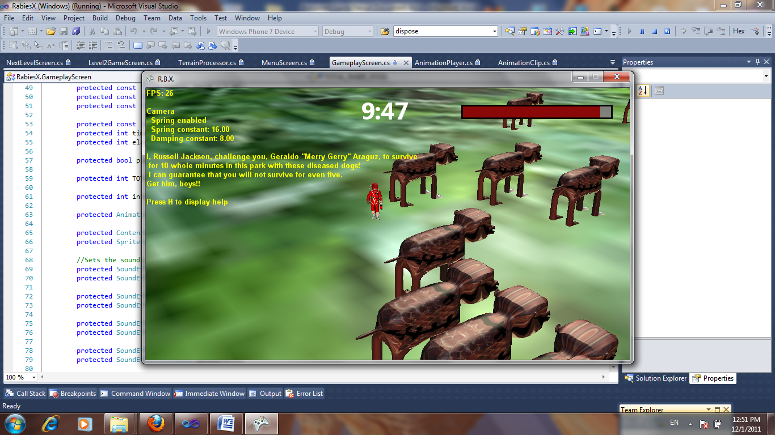

Araguz and the dogs

Section 1: Game Overview

Basic Summary:

This game is created by the Araguzers – Michael Minkov Jr., Nashid Shabazz, Isiah Aideyan, Eddie Grigoreff and Chris Lopez - with the help of their mentors, Jose Baez-Franceschi and Dr. Chang Yun. It is called R.B.X., which is a “mysterious” acronym given to a new disease that has struck the dogs of Planet Earth. The outbreak is horrible and it is spreading very fast. While Geraldo Araguz, a renowned world-famous astronaut and decorated war hero, is exploring Space, this horrific new disease has struck Planet Earth. Araguz is officially known to be the most decorated soldier in the US army as well as a professional pest control specialist, so the US government describes to him in detail what’s going on, and gives him a mission. That mission is short and sweet. The virus was created by a very bad man. He has purposefully infected dogs with it and released them into specific areas of the world. Araguz must go to those areas, cure the dogs with a plasma ray emanating from his plasma gun, and collect samples of the virus. Geraldo Araguz must collect just enough samples to form a new vaccine. Russell Jackson is the villain who did this, and he somehow seems to know Geraldo Araguz – as he taunts him, daring him to survive with the diseased dogs.

Goals and Features:

As stated above, Araguz has to cure the dogs and collect virus samples, represented on the game terrain as a set of corked bottles. There are two levels. One is a park level which contains 20 dogs. The other one is harder: a desert with 40 dogs. Araguz has 10 minutes to complete his task in each level. Once he cures the dogs and collects all the samples, the level is won.

Of course, to achieve this very goal, Araguz must first of all stay alive. Every time a dog gets too close, Araguz loses health. Whenever his health goes to zero, he is infected beyond repair and so the game is lost. If the time has expired but there are either unhealed dogs or uncollected samples remaining, the game is lost. Russell Jackson teases Araguz whenever he loses the game.

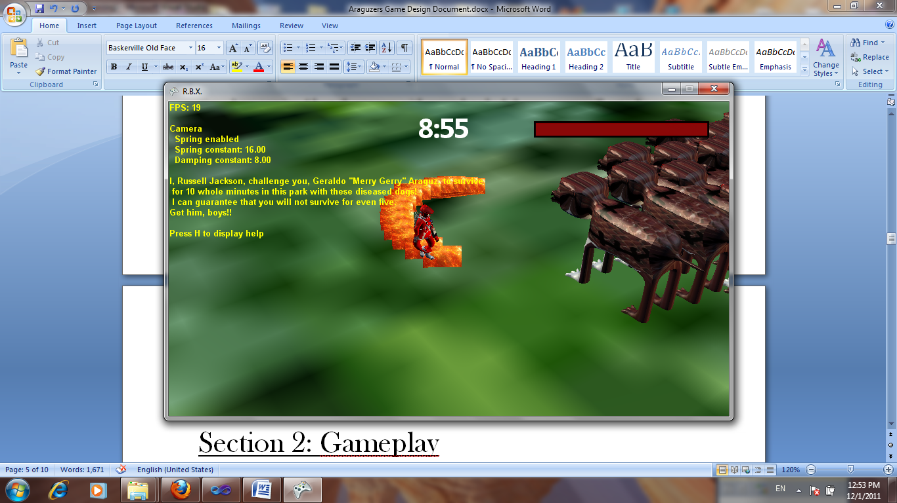

Plasma ray

Section 2: Gameplay

When the player fires up the game, he/she will have a start menu with several options. The start menu screen, along with the rest of the screens, is implemented using C#/Visual Studio 2010. The player can hit “Play Game”. Due to time constraints, we have made this a single-player game.

Once the game officially starts, the introductory cinematic will commence. It discusses the storyline, the problem, the solution to the problem, as well as gameplay. It will incorporate government agents giving Araguz the mission. The analogy of the intro cinematic preceding the game is like an abstract preceding a research paper. It attracts the player to the game just like the abstract attracts the reader to the paper.

Finally, the game commences. The main protagonist, Astronaut/Pest Control Specialist Geraldo Araguz, will be standing in the park and looking for dogs – the player will be controlling where he goes. As the game commences, a government agent will be telling him through his intercom to go to the park, yet Araguz is already there – so he will wonder if he’s a telepath or something. Then, she’ll tell him to collect the samples, and Araguz will demonstrate his confidence. The dogs will be a threat to him, and he will be curing them using his plasma gun. An orange ray will do the job. Whenever a dog is cured, it will be replaced by the set of corked bottles that represents the sample Araguz must collect.

Section 3: The Levels

There are two levels, and in the next version of the game we are planning to implement more.

The first level takes place in a grassy park. There are 20 dogs. Araguz has 10 minutes, or the dogs will be loose in the city. The key controls will be explained in a later section. Araguz and government Agent Fiona McDade have a short discussion over Araguz’s intercom. When 20 dogs are cured and 20 sets of samples are collected, Araguz yells “in your face, Jackson!” and Jackson shows defeat. Then, government agent Damon Viridian talks to Araguz via the intercom and tells him to go to Zanzibar, where there are yet more diseased dogs to heal.

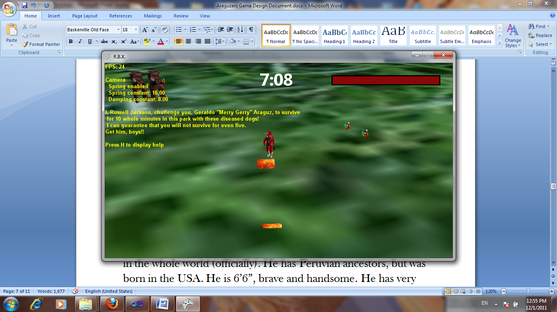

Zanzibar is where the second level takes place. There are 40 dogs there, so it is more challenging. Araguz once again demonstrates his superior confidence and fires that benevolent plasma ray on the dogs. Same concept as that of level 1, yet harder.

Section 4: The Main Protagonist

World-famous astronaut Geraldo Araguz is the main protagonist of R.B.X. Here is a recap: he is considered to be the bravest man in the whole world (officially). He has Peruvian ancestors, but was born in the USA. He is 6’6”, brave and handsome. He has very high self esteem. He served in the US army and became a decorated war hero, a young one at 28 years of age. All of these reasons combined are why he, and no one else, was chosen to do this mission. He is told by the US government to cure the diseased dogs and gather virus samples for a vaccine.

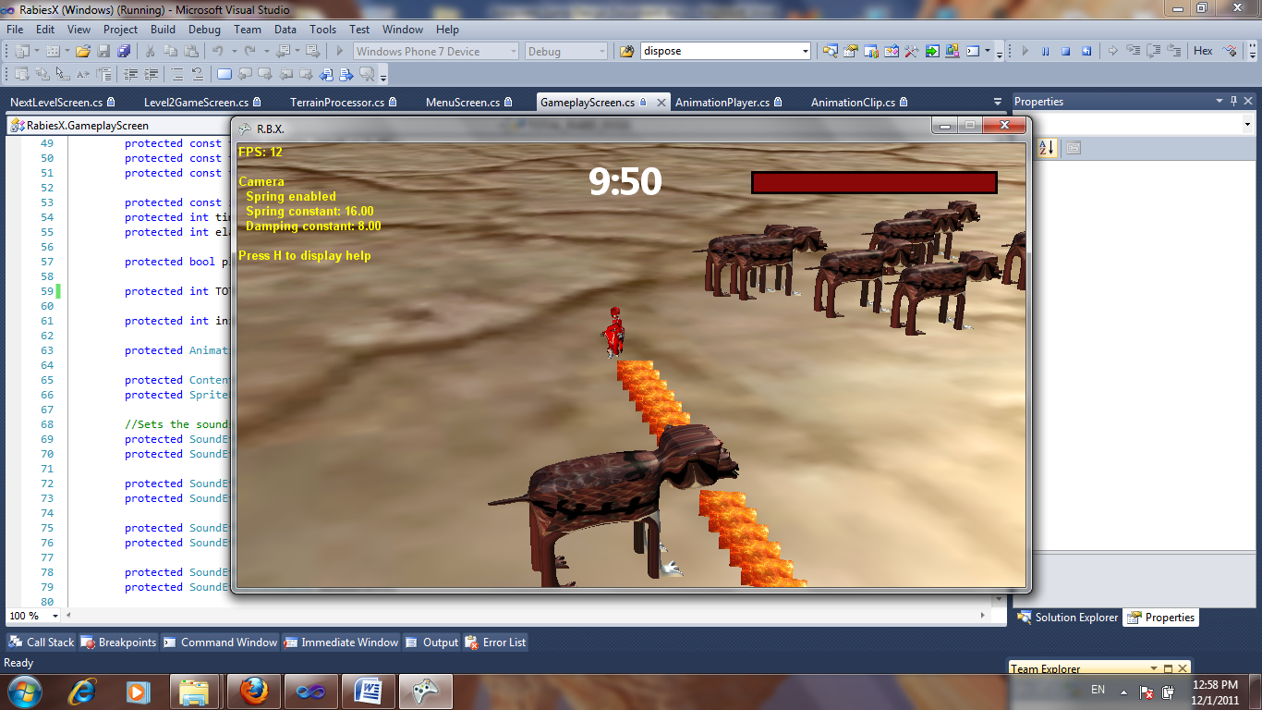

Section 5: Enemies

Well we would not really call the dogs enemies – they are more like obstacles. Yet they are the ones that need healing. They are big, and they look diseased. And they are. They are a threat to Geraldo Araguz if they breathe too much of the virus on him, but he is able to heal himself. Watch out when they surround you – Araguz will not be able to get away.

Section 6: The Main Antagonist

During the regular levels, Russell Jackson taunts Geraldo Araguz from the beyond. He seems to know him from somewhere. He was the evil genius with a big grudge who created the new virus and purposefully gave it to the dogs. Whenever Geraldo Araguz loses the game, he will say “You lose, Geraldo Araguz! Ha ha ha ha ha!” – but when Araguz wins, Jackson will yell out “Noooooooo!”, admitting defeat. Jackson’s taunt can be seen on the game screen.

Section 7: The Vehicle

Whenever Geraldo Araguz wins the park level, his government-crafted and –given GuzCruise (vehicle on crawlers named after him) will show up on the map. This type of vehicle can fly, and so he will have to come on board and fly it to Zanzibar.

Section 8: Health

Health is an attribute that Geraldo Araguz has. It will be represented by a health bar on the upper-right side of the screen. When it is all red, that means Araguz is 100% healthy. When the dogs infect him, the red part will decrease and Araguz will lose health. The dogs don’t really have “health”, but they get healed more whenever Araguz fires the ray on them. When Araguz’s health is down to 0, he dies from disease and the game is lost. Geraldo Araguz can heal himself when the user presses the “Page Up” key.

Section 9: Controls

This is how the player controls Geraldo Araguz. In this version, he faces the player.

To move backward, away from the player: “W” or Up Arrow.

To turn to the right: “D” or Right Arrow.

To turn to the left: “A” or Left Arrow.

To move forward, towards the player: “S” or Down Arrow.

To shoot the curing plasma ray: Right Control key. Hold it down to create a true ray as opposed to discrete quanta. Be sure to aim it at the dogs.

To heal: Hold down the Page Up key.

If you want to quit a level for a reason, you can hit the “esc” key for a menu – or you can purposefully stand in front of a dog – or you can hold the “Page Down” key!

Press “Enter” to select menu items. On a menu, press the Down Arrow to toggle between the entries.

To maximize/minimize the game screen: “Alt” + “Enter”

To pause the game: “esc” key.

Section 10: Platforms/Technologies

This game is to be run on the Windows OS, for any regular PC. The models of the protagonist, dogs, sample bottles, etc. are made in Autodesk Maya. The code is written using Visual Studio with imported XNA libraries, FBX models, as well as various images to be used for items like sky, terrain, etc.

Section 11: Terrain and Sky

Bitmaps are used for the terrain and the sky. Images are picked from the public domain, and then are resized to powers of two and saved as bitmaps. They have to have at most 2^16 triangles in their polygonal makeup. Those bitmaps are processed by XNA code that deals with terrain and the sky – there are XNA modules for that, terrain processors and sky processors. The terrain and sky are declared as objects in the gameplay screen, along with their respective bounding spheres. When the game is run, the images are shown in the forms of terrain and sky as a result.